FASHION DEMAND FORECASTING USING MACHINE LEARNING AND DOMAIN ADAPTATION
Conclusion, Future Scope and References
Department of Computer Science and Engineering, TKR College of Engineering & Technology
Batch A17 (CSE-A) · Academic year [ACADEMIC YEAR]
Table 1: Project team
S.No. | Student name | Roll number
1 | B Shilpa | 23K91A0547
2 | B Hari Narayana | 23K91A0544
3 | A Rani Thejaswini | 23K91A0516
4 | A Sanjana | 23K91A0511

Project guide: Deepthi
Chapter and section numbers quoted in the text (for example Chapter 8 or Section 6.2) refer to the full project report, 17.Final Document. Figures and tables in this document are numbered from 1.

1. CONCLUSION

1.1 Summary
TrendCast is a working forecasting product: it turns H&M-style transactions into daily demand per article, forecasts it with XGBoost and offers an importance-weighted domain-adaptation workflow, behind a gated 22-route API and a 13-page console. Measured on 684,392 real transactions of 300 articles over 107 days, the honest outcome is mixed, and the documents say so.

1.2 Objectives against outcomes
Table 2: Objectives against outcomes
Objective | Outcome | Evidence
1 Collect real data, engineer seasonal, price and category features | Achieved | H&M subset, 31 inputs, shifted lags, no promotions or fabric in the data
2 Train XGBoost at product and category level | Product level achieved | Article-level model; category enters as features only
3 Apply domain adaptation across markets and categories | Implemented | Importance weighting on channel, group and department; no regional markets in the data
4 Compare adapted and non-adapted on a shifted target | Done; result negative or mixed | 2 of 6 pairs improved; mean -14.6 percent
5 Explain forecast drivers | Partly | Gain importance in the app; offline SHAP agrees only moderately (Spearman 0.40)
6 Evaluate with MAE, RMSE, MAPE and inventory impact | Metrics yes; inventory offline | XGBoost under-forecasts 16.4 percent and over-forecasts 39.9 percent of test demand

1.3 Key findings
1. The model is useful but not unbeatable. On the real test window XGBoost (RMSE 11.09, R2 0.33) beats the moving average (12.89) and random forest (13.26); LightGBM (10.06) and the tuned model (10.34) come closer to naive lag-1 (9.22), which still wins.
2. Recent demand does the work. Without lag and rolling features R2 falls to -0.41; with only those features RMSE is 9.40, better than the shipped all-feature model. This agrees with the base paper's own ablation on different data.
3. Domain adaptation, as shipped, is not a reliable gain. It improved 2 of 6 pairs; the one clear gain disappears when source rows may not overlap the target test dates (-7.1 percent on average in that protocol).
4. Weights must be normalised. Perfectly separable domains produce weights near 1e-5 and XGBoost predicts a constant; rescaling the same weights to mean 1 removes the collapse.
5. Multi-day forecasts are weak. WAPE grows from 41 to 124 percent over the horizon, worse than a flat seven-day mean at every horizon.
The abstract's claim that the system reduces shortages and overstock is not demonstrated: on the test window XGBoost over-forecasts total demand by 23.6 percent while losing fewer sales than the moving average (16.4 against 29.4 percent of demand).

1.4 Closing remark
The project's value is the measured, reproducible pipeline and the controls that expose where adaptation and recursive forecasting fail. With normalised weights, a time-clean protocol and refreshed calendar features, the same code is a sound base for a real study.
The measurements behind the key findings are shown below: how the models compare on the held-out window, and how the relative results sit next to those reported in the base paper (different data, so indicative only).
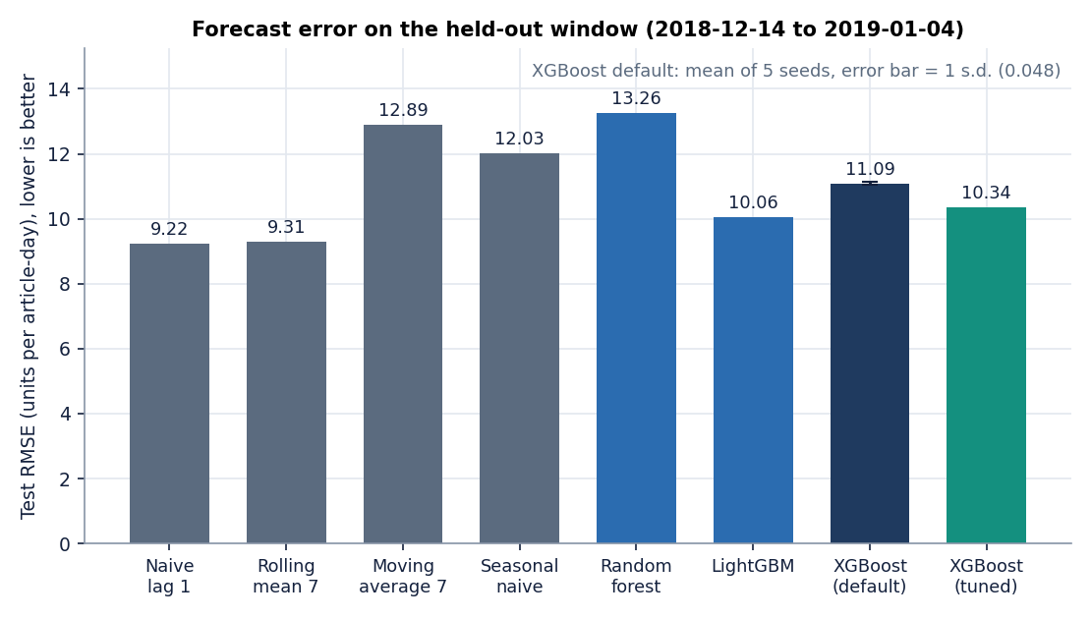
Figure 1: Test RMSE of the baselines and of XGBoost on the real H&M subset (chronological 80/20 split).
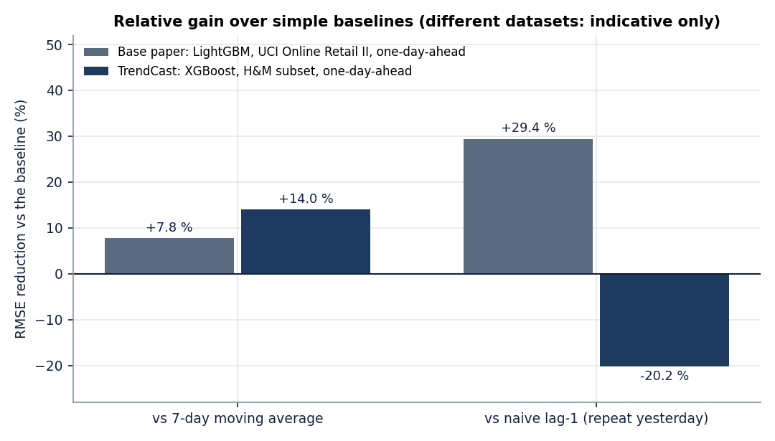
Figure 2: Relative RMSE against the moving average and the naive forecast in the base paper and in TrendCast: different datasets, indicative only.

2. FUTURE SCOPE

2.1 Repair the weaknesses found
• Normalise the weights to mean 1 and floor them, and report the effective sample size on screen; the offline study shows this removes the collapse on perfectly separable domains.
• Make the time-clean protocol the default: train the source model only on dates before the target test window, so the before-and-after comparison cannot gain from the future.
• Refresh every calendar feature in the recursive loop, update price and channel from a plan, and compare against a flat seven-day mean automatically.
• Drop or regularise absolute-time features (year, quarter, day of year) and keep duplicate rows, which are repeat purchases.

2.2 Add features
• A cold-start mode that forecasts a new article from attributes, calendar and similar products, in the spirit of the new-product models in the literature [18], [22].
• SHAP in the app for global and per-forecast attribution, as in the base paper [1], plus an inventory view that turns error into under- and over-stock units.
• Direct multi-horizon models and probabilistic forecasts (quantiles) instead of recursion.

2.3 Data, methods and deployment
• Run on the full H&M dataset and add promotion, regional and weather data where they exist; test transfer to a genuinely new market.
• Compare importance weighting with CORAL and adversarial adaptation [16], [15] and with simple pooling.
• Add authentication, a database, multi-user sessions, scheduled retraining and drift monitoring, and measure load on the full dataset.
The order matters: the repairs in the first stage are small, testable and should be done before any new feature is added, because the other stages build on a forecast that must at least match a flat seven-day mean.
Table 3: Roadmap
Stage | Work | Done when
1. Repair what was measured | Normalise weights, time-clean protocol as default, refresh all calendar features in recursion, keep duplicate rows, drop absolute-time features | The six-pair study improves or is neutral, and the recursive forecast beats a flat seven-day mean
2. Explain and plan | SHAP per forecast, WAPE and under/over-stock units in the app, a naive lag-1 row in the comparison table | Planners see why a number moved and how much stock it risks
3. Widen the data | Full H&M, regions and promotions where available, a second retailer | Results repeat on a window with a previous year
4. Deploy | Authentication, a database, scheduled retraining and monitoring | Several users can work on separate datasets

3. REFERENCES
[1] L. N. Mishra, B. Senapati, S. K. Nayak and A. J. Rangari, "Explainable retail demand forecasting: A hybrid LightGBM-SHAP framework for inventory optimization," IEEE Access, vol. 14, pp. 43613-43633, 2026, doi: 10.1109/ACCESS.2026.3675540.
[2] T. Chen and C. Guestrin, "XGBoost: A scalable tree boosting system," in Proc. 22nd ACM SIGKDD Int. Conf. Knowledge Discovery and Data Mining, Aug. 2016, pp. 785-794.
[3] G. Ke, Q. Meng, T. Finley, T. Wang, W. Chen, W. Ma, Q. Ye and T.-Y. Liu, "LightGBM: A highly efficient gradient boosting decision tree," in Proc. Advances in Neural Information Processing Systems (NIPS), 2017, pp. 3146-3154.
[4] S. M. Lundberg and S.-I. Lee, "A unified approach to interpreting model predictions," in Proc. Advances in Neural Information Processing Systems (NIPS), 2017, pp. 4765-4774.
[5] S. M. Lundberg et al., "From local explanations to global understanding with explainable AI for trees," Nature Machine Intelligence, vol. 2, no. 1, pp. 56-67, Jan. 2020.
[6] S. Makridakis, E. Spiliotis and V. Assimakopoulos, "M5 accuracy competition: Results, findings, and conclusions," International Journal of Forecasting, vol. 38, no. 4, pp. 1346-1364, Oct. 2022.
[7] L. Breiman, "Random forests," Machine Learning, vol. 45, no. 1, pp. 5-32, 2001.
[8] J. H. Friedman, "Greedy function approximation: A gradient boosting machine," The Annals of Statistics, vol. 29, no. 5, pp. 1189-1232, 2001.
[9] R. J. Hyndman and A. B. Koehler, "Another look at measures of forecast accuracy," International Journal of Forecasting, vol. 22, no. 4, pp. 679-688, 2006.
[10] H. Shimodaira, "Improving predictive inference under covariate shift by weighting the log-likelihood function," Journal of Statistical Planning and Inference, vol. 90, no. 2, pp. 227-244, 2000.
[11] M. Sugiyama, M. Krauledat and K.-R. Mueller, "Covariate shift adaptation by importance weighted cross validation," Journal of Machine Learning Research, vol. 8, pp. 985-1005, 2007.
[12] S. Bickel, M. Brueckner and T. Scheffer, "Discriminative learning under covariate shift," Journal of Machine Learning Research, vol. 10, pp. 2137-2155, 2009.
[13] S. J. Pan and Q. Yang, "A survey on transfer learning," IEEE Transactions on Knowledge and Data Engineering, vol. 22, no. 10, pp. 1345-1359, Oct. 2010.
[14] S. Ben-David, J. Blitzer, K. Crammer, A. Kulesza, F. Pereira and J. W. Vaughan, "A theory of learning from different domains," Machine Learning, vol. 79, no. 1-2, pp. 151-175, 2010.
[15] Y. Ganin et al., "Domain-adversarial training of neural networks," Journal of Machine Learning Research, vol. 17, no. 59, pp. 1-35, 2016.
[16] B. Sun and K. Saenko, "Deep CORAL: Correlation alignment for deep domain adaptation," in Proc. ECCV Workshops, 2016, pp. 443-450.
[17] S. Thomassey, "Sales forecasts in clothing industry: The key success factor of the supply chain management," International Journal of Production Economics, vol. 128, no. 2, pp. 470-483, Dec. 2010.
[18] V. Ekambaram, K. Manglik, S. Mukherjee, S. S. K. Sajja, S. Dwivedi and V. Raykar, "Attention based multi-modal new product sales time-series forecasting," in Proc. 26th ACM SIGKDD Int. Conf. Knowledge Discovery and Data Mining, 2020, pp. 3110-3118, doi: 10.1145/3394486.3403362.
[19] P. K. Singh, Y. Gupta, N. Jha and A. Rajan, "Fashion retail: Forecasting demand for new items," arXiv:1907.01960, 2019.
[20] G. Skenderi, C. Joppi, M. Denitto and M. Cristani, "Well Googled is half done: Multimodal forecasting of new fashion product sales with image-based Google Trends," arXiv:2109.09824, 2021 (rev. 2024).
[21] S. I. Papadopoulos, C. Koutlis, S. Papadopoulos and I. Kompatsiaris, "Multimodal quasi-autoregression: Forecasting the visual popularity of new fashion products," arXiv:2204.04014, 2022.
[22] R. Zhou, Z. Zhang, J. Han, Y. Peng and X. Zhang, "Cold-start forecasting of new product life-cycles via conditional diffusion models," arXiv:2604.20370, Apr. 2026.
[23] H&M Group, "H&M Personalized Fashion Recommendations," Kaggle competition data (articles, customers, transactions), 2022. [Online]. Available: https://www.kaggle.com/competitions/h-and-m-personalized-fashion-recommendations
[24] F. Pedregosa et al., "Scikit-learn: Machine learning in Python," Journal of Machine Learning Research, vol. 12, pp. 2825-2830, 2011.
[25] J. Bergstra and Y. Bengio, "Random search for hyper-parameter optimization," Journal of Machine Learning Research, vol. 13, pp. 281-305, 2012.
[26] "Impact of AI-driven demand forecasting on retail inventory efficiency," 2026 (title as listed in the batch literature survey; not located online and not quoted).
[27] "Enhancing inventory planning in retail SMEs through data-driven demand forecasting," Int. J. of Innovative Inventions in Social Science and Humanities, 2026 (title as listed in the batch literature survey; not located online and not quoted).
[28] "Does the forecaster matter? A systematic evaluation of demand forecasting and inventory control policies across retail demand regimes," 2026 (title as listed in the batch literature survey; not located online and not quoted).
[29] "Predictive inventory management for retail distribution networks: Reorder point optimization and machine learning demand forecasting," 2026 (title as listed in the batch literature survey; not located online and not quoted).

